高考英语
书面表达精练10篇 直击高考10篇
江西黄少华
即学即练
精练 1
假设你是晨光中学的学生会主席李华。学生会将举办每年一度的英语演讲比赛，本年度的主题为“The English Novel I Like Best”。作为组织者，你将在演讲比赛开幕时发言，请你根据以下提示用英语写一篇发言稿。
1. 说明比赛的意义，如提高英语听说能力，养成读书的习惯等；
2. 说明比赛的注意事项，如每人演讲不超过5分钟，语言流利，发音准确等；
3. 预祝比赛圆满成功。
注意：
- 词数：不少于100词；
- 可适当加入细节，以使行文连贯；
- 发言稿的开头和结尾已为你写好，不计入词数。
Good afternoon, ladies and gentlemen,
Welcome to this year’s English speech competition.
此处不能答题
Thank you!
精练 2
假设你是李华。你的外国笔友Jane打算于七月来中国，特来信了解中国人的社交习俗。请你用英语回一封信，从以下几个方面作具体介绍。
- 见面时的问候方式；
- 对毛病的回答方式；
- 接收礼物时的回应方式；
- 餐宴礼节。
注意：
- 词数100左右，信的开头和结束语已为你写好（不计入总词数）。
- 可根据内容要点适当增加细节，使行文连贯。
Dear Jane,
Glad to hear from you and you’re welcome to China in July.

_______________________________________________________________________
____________________________________________________________________________
I hope what’s mentioned above might be helpful and wish you a good journey.
精练3
假设你正在参加全省中学生英语演讲比赛，请你针对有些父母经常翻看孩子日记或书包这一现象，写一篇演讲稿，陈述你的观点。
演讲稿的主要内容应包括：
认为同学们不必为此苦恼；
希望能够体谅父母的苦衷；
建议与父母进行交流和沟通。注意：
1. 词数100左右；
2. 可以适当增加细节，以使行文连贯；
3. 开头和结尾已为你写好，不计入总词数。
Good morning, ladies and gentleman.
Some of us are having problems with our parents, as they often look into our school bags or read our diaries.

___________________________________________________________________________
__________________________________________________________________________
___________________________________________________________________________
Thank you!
精练 4
假设你是李华，曾在美国学习半年，现已回国。你想联系你的美国老师Mr. Smith,但没有其联系方式。请根据以下要点给你的美国同学Tom 写一封信：
- 感谢Tom对你英语学习的帮助；
- 询问Mr, smith 的近况并索要其联系方式；
- 邀请Tom在春节期间来中国感受中国文化。
注意：1. 词数120-150；
2．可适当增加细节。
______________________________________________________________________________________________________________________________________________________________________________________________________________________________________________________________________________________________________________________________________
___________________________________________________________________________________
精练5
学校即将举行以“Turning a bad mood（心情）into a good one ”为题目的英语作文比赛，请按下列要求定一篇100词左右的记叙文或议论文。
记叙文 议论文
- 好心情的重要性。
- 产生坏心情的原因。
- 应该如何调整心情。
- 发生的具体事件。
- 对你的心情有何影响？
- 你如何应对？

____________________________________________________________________________________________________________________________________________________________________________________________________________________________________________________________________________________________________________________________________________
___________________________________________________________________________________
精练6
鼠标是计算机时代最佳的人机交互工具之一。它极大地方便了人们的计算机操作。但是，过分依赖鼠标的习惯也会带来一些不利影响。请你以鼠标为切入点，根据下表所提示的信息，用英语写一篇短文。
鼠标的必要性 | 对多数人来说，操作计算机，上网冲浪……
鼠标的便捷性 | 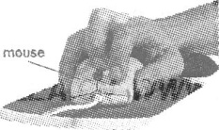  点击、移动、插入、拷贝、删除…… | 编辑文本，搜索信息……
鼠标的便捷性 |  | 收发邮件，选购商品……
鼠标的便捷性 |  | 点播音乐，下载电影……
如果过分依赖鼠标……请考生结合自身感受，列举两到三点）

注意：
1．对所给要点逐一陈述，适当发挥，不要简单翻译。
2．词数150左右。开头已经写好，不计人总词数。
3．作文中不得提及考生所在学校和本人姓名。
The mouse is a most effective device used by people to communicate with a computer．
______________________________________________________________________________
____________________________________________________________________________________________________________________________________________________________________________________________________________________________________________________________________________________________________________________________________________
精练7
假设你是某中学新老师李红，请给你的朋友张华写一封信，告诉他你第一天上课的情况，主要内容如下：
1. 描述一件课堂上令你印象深刻的事情；
2. 介绍你处理该事的方式；
3. 谈谈你的感想。
注意：
1. 词数不少于120个；
2. 可适当发挥想象，增加细节，以使行文连贯；
3. 文中不得出现与本人及学校相关的任何真实信息。
___________________________________________________________________________________________________________________________________________________________________________________________________________________________________________________________________________________________________________________________________________________________________________________________________________________________
精练8
假设你是育才中学学生会主席李华。你校将举办一次英语演讲比赛(speech
contest).希望附近某大学的外籍教师Smith女士来做评委。请参照以下比赛通知给她写
一封信。
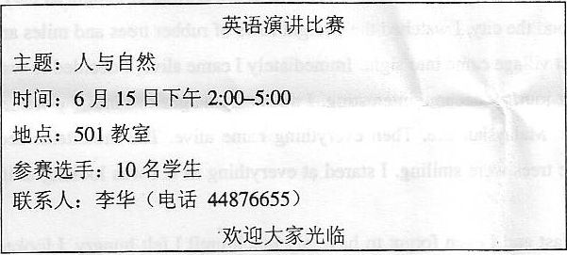
注意：词数100左右。
With best wishes,
____________________________________________________________________________________________________________________________________________________________________________________________________________________________________________________________________________________________________________________________________________
___________________________________________________________________________________
精练9
假设你是红星中学高二(1)班的学生李华，利用上周末的时间帮助祖父母安排了去北戴河的旅行。请根据以下四幅图的先后顺序，写一篇英文周记，叙述你从准备到送行的全过程。
注意：1.周记的开头已为你写好。 2.词数不少于60。
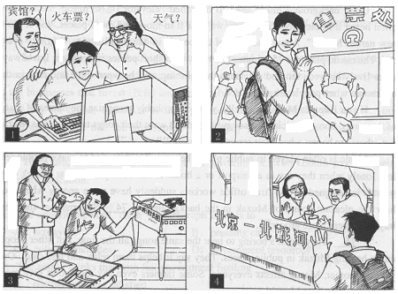
Last weekend, I helped my grandparents prepare their trip to Beidaihe. ______________
_______________________________________________________________________
_______________________________________________________________________
_______________________________________________________________________
_______________________________________________________________________
_______________________________________________________________________
精练10
假设你是李华，于2010年6月3日搭乘国外某航空公司航班（flight number BA793）回国后，发现遗失了一个行李箱（suitcase）。现请用英文给该航空公司写一封信，请他们帮你寻找。
信件要点包括：
- 陈述写信原因
- 简要描述该行李
- 说明其重要性
- 期待回复并表示感谢
注意：
1. 词数100左右。
2. 信件格式已为你给出。
3. 请在答题卡上作答。
___________________________________________________________________________________________________________________________________________________________________________________________________________________________________________________________________________________________________________________________________________________________________________________________________________________________
直击高考
1.（2014·安徽卷）
为了帮助中学生健康成长，某中学英文报开辟了“HEART-TO-HEART”专栏。假设你是该栏目的编辑Jamie，收到一封署名为Worried的求助信。信中该同学向你诉说了自己的困扰：近日容易发脾气，使正常的学习和生活受到了影响。请用英文给该同学写一封回信。
内容要点如下：1．表示理解并给予安慰；2．提出建议并说明理由。
注意：1．词数120左右；2．信中不能出现与本人相关的信息；
3．信的开头与结尾已为你拟好，不计入总词数。
参考词汇：temper n. 脾气，情绪
Hi Worried，
I’m sorry to know that you’re having such a had time at the moment. ________
_______
______________
_________________________________________________________________________________
Yours,
- （2014·北京卷）
第一节 （15分）
你给英国朋友Chris写一封信，内容包括： 1.你们原计划7月份一同去云南旅游；2.由于脚部受伤，你无法按原计划前往；3.表达你的歉意并建议将旅行推迟到8月份。
注意： 1.词数不少于50. 2. 可适当增加细节，以使行文连贯。 3.开头和结尾已给出，不计入总词数。
Dear Chris,
_________________________________________________________________________________________________________________________________________________________________________________________________________________________________________________________
Yours,
Joe
第二节（20 分）
假设你是红星中学高三（1）班的学生李华，请根据以下四幅图的先后顺序，用校刊“英语园地”写一篇短文，记述你和同学们向学校提建议，解决自行车存放问题的过程。
注意： 1. 词数不少于 60. 2. 短文的开头已给出，不计入总词数。
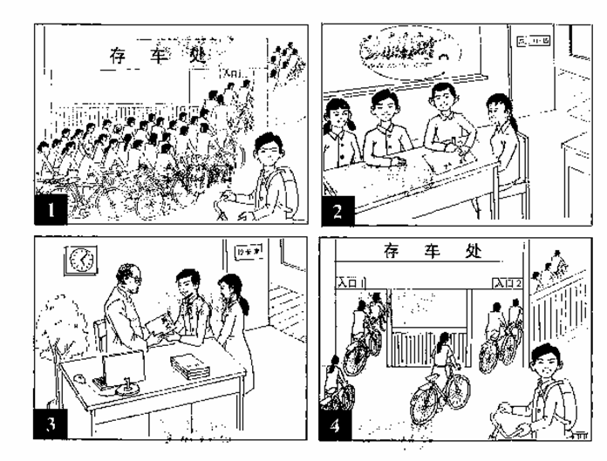
There was a problem with the parking place for bikes in our school.
3.（2014·全国大纲卷）
一家英语报社向中学生征文，主题是“十年后的我”，请根据下列要求和你的想象完成短文、家庭工作业余生活
注意：1、次数100左右；
2、可以适当增加细节，以使行文连贯；
3. 开头语已为你写好
I often imagine what my life will be like in the future.
___________________________________________________________________________________________________________________________________________________________________
________________________________________________________________________________
________________________________________________________________________________
4.（2014·福建卷）
如何理解“成功”，不同的人有不同的看法。请认真阅读下面的引语( quotation)，按要求用英语写一篇短文。
“Success is the ability to go from one failure to another with no loss of enthusiasm."
- Sir Winston, Churchill
内容要求：
1．你对该引语的理解： 2．你的相关经历： 3．恰当的结尾。
注意：
1．短文开头已给出，不计入总词数： 2．文中不能出现考生的具体信息： 3．词数：120左右。
This quotation from Winston Churchill tells us that _________________________________
__________________________________________________________________________
__________________________________________________________________________.
5.（2014·广东卷）
第一节 基础习作
你接受一项写作任务，要为当地英语晚报写一篇报道。
［写作内容］
请根据以下信息写一篇英文报道，内容包括：
人物：英国人查理德·阿维斯（Richard Avis）
出生日期：1974年12月1日
时间：2011年开始在世界各地寻找同年同月同日生的人
目的：理解不同文化中成功人生的含义
相关信息：
- 借助当地媒体寻找
- 迄今找到32名，其中男性17名，女性15名，来自13个国家
- 职业包括政府官员、运动员、司机、教师、艺术家等
- 计划40岁生日前找到40位同年同月同日生的人
- 打算根据此经历写一本书
同年同月同日生的人：time twin
［写作要求］ 只能用5个句子表达全部内容
［评分标准］ 句子结构准确，信息内容完整，篇章结构连贯。
第二节 读写任务（共1小题；满分25分）
阅读下面短文，然后按照要求写一篇150词左右的英语短文。
Oseola McCarty spent more than 75 years washing and ironing other people’s clothes. As a laundrywoman, she was paid only a few dollars each time. Certainly nobody would consider her rich, so they were all amazed when Miss McCarty decided to donate $ 150,000 to the University of Southern Mississippi.
The money was i … me savings. She could save such a large amount of money because she lived a very simple life. She never learned to drive, and when she wanted to go somewhere, she just walked. She never flew to anywhere till the donation（捐助），and in 50 years she had been out of the South only once. The house in which she lived was also a rather modest one her last uncle left her. Only after she became known in America did she begin to travel all over the country. Since then, she had been the subject of many interviews and articles and was even invited to the White House.
Her donation was for students who clearly needed financial help. She herself left school in the sixth grade and had never married or had children. She said to the reporters that the idea of helping somebody’s child go to college gave her much pleasure.
[写作内容]
- 用约30个词概括上文的主要内容。
- 用约120个词就Miss McCarty的捐助谈谈你的想法，内容包括：你如何看待她的捐助行为；你认为她的捐助对受惠学生有哪些影响；如果你自己要捐助，你会选择哪个群体并陈述理由。
[写作要求]
作文中可以使用亲身经历或虚构的故事，也可以参照阅读材料的内容，但不得直接引用原文的句子。作文中不得出现真实姓名和学校名称。
[评分标准]
概括准确，语言规范，内容合适，篇章连贯。
6.（2014·湖北卷）
请根据以下提示，并结合具体事例，用英语写一篇短文。
Small things make a big difference. The small things we do can make us a responsible member of the society.
注意：①无须写标题；②除诗歌外，文体不限；③内容必须结合你生活中的具体事例；
④文中不得透露个人姓名和学校名称； ⑤词数不少于120，如引用提示语则不计入总词数。
7.（2014·江苏卷）
阅读下面短文，并按照要求用英语写一篇150词左右的文章。
When we read newspapers, we often come across such English words as "AIDS" and "PK." When we watch TV, we frequently hear words like "NBA" or "PM2.5." When we speak, we automatically use words like "OUT" or "Bye-bye." English words and expressions like these are getting popular. They have already become part of our daily language. And 239 English words have been included in the latest Dictionary of Contemporary Chinese.
The inclusion has started a heated discussion. A group of scholars signed a letter of complaint over the inclusion of these English words, which, they think, goes against Chinese language policies. They not only worry that Chinese is borrowing an increasing number of English words but are also concerned that the inclusion may hurt the dignity of the Chinese language. However, others are in favor of the inclusion because it is hard to say whether it will threaten the Chinese language. They believe the selection is mostly a result of their function and use in daily life.
【写作内容】
用约30个单词写出上文概要；用约120个单词发表你的观点，内容包括：
（1）支持或反对汉语词典收录英语词汇；（2）用2-3个理由或论据支撑你的观点。
【写作要求】
1.可以支持文中任一观点，但必须提供理由或论据；2.阐述观点或提供论据时,不能直接引用原文语句;
3.作文中不能出现真实姓名和学校名称；4.不必写标题。
【评分标准】内容完整，语言规范，语篇连贯，词数适当。
8.（2014·江西卷）
假定你是星光中学的高中毕业生李华，母校将为高一新生举办主题为“What to learn in senior high school?”的英语沙龙活动，特邀请你结合自身经历谈谈自己的体会。请根据以下提示准备一份英语发言稿。
1.学会学习：方法，习惯等； 2.学会做人：真诚，友善；
3.学会其他：考生自拟。
注意：1.词数120左右； 2.发言稿开头和结尾已给出，不须抄在答题卡上，不计入总次数。
Good morning, everyone! It is my honor to be here to share with you my opinions on what to learn in senior high school.
______________________________________________________________________________________________________________________________________________________________
Thank you!
9.（2014·辽宁卷）
假定你是学生会主席李华。学校将举办一次以“校园生活，创意无限”（innovations on campus）为主题的创意作品展评活动。请你根据以下图示，以短文形式用英语写一份书面通知。
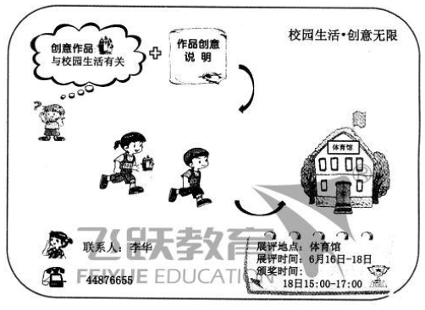
注意：1．词数100左右； 2．可以适当增加细节，以使行文连贯。
3. 开头及结尾已为你写好，不计入总词数。
参考词汇：校园campus 创意作品innovation 颁奖prize-giving

书面表达精练10篇 直击高考10篇答案详解
精练1：
Good afternoon. Ladies and gentlemen.
Welcome to this year’s English speech competition. Taking part in English speech competition is a helpful way to learn English. While we fully prepare for the competition, we can improve our abilities of listening and speaking and develop a good habit of reading English. In the process of the competition, you should pay special attention to the following rules. First, you should finish your speech in five minutes. Second, you try your best to express yourself in English fluently. Finally, you should have a good English pronunciation.
I hope that the English speech competition will be a great success!
Thank you!
精练2：
Dear Jane,
Glad to hear from you and you’re welcome to China in July. The following are some Chinese customs.
Firstly, we greet each other by saying “Hello” or asking such questions as “Where are you going?” or “Are you busy?” to express our care. Secondly, when praised, we reply with “Oh, no!” or “I’m over-praised” to show good manners. Next, when receiving a gift, we usually say “It’s unnecessary” besides “Thanks” to show politeness and then put it away. Finally, at dinner parties, we talk loudly and touch glasses when drinking to someone’s health or success to show that we’re warm.
Anyhow, different cultures, different customs. If you “Do as the Romans do when in Rome”, you’ll enjoy more of your staying here.
I hope what’s mentioned above might be helpful and wish you a good journey.
Yours sincerely,
Li Hua
精练3：
Good morning, ladies and gentlemen.
Some of us are having problems with our parents, as they often look into our school bags or read our diaries. I fully understand why we are not comfortable about it, but there’s no need to feel too sad. Our parents are checking our bags or diaries to make sure we’re not getting into any trouble. They have probably heard some horrible stories about other kids and thought we might do the same. Or perhaps they just want to connect with us but are doing it all wrong. My suggestion is: Tell them we want them to trust us as much as we’d like to trust them. If you don’t think you can talk to them, write them a letter and leave it lying around—thy are bound to read it.
Thank you!
精练4：
Dear Tom,
I am now back China and sound. In this letter I would like to convey my heartfelt appreciation to you for your kind assistance in my English learning when I was in New York. Additionally, your generous help and tender care made me feel warmly welcomed and transformed my first American trip into a unforgettable memory.
I have been missing our English professor, Mr. Smith whose unusual cast of mind, wide and varied knowledge, together with a singular personal charm, combined to exert a strong influence on me. What about him recently? I desire to contact him for some suggestions on improving my listening ability. However, his email address is not available. So would you mind delivering it to me via the online mailbox?
I am more than delighted to invite you to join us to celebrate the Spring Festival -Chinese Lunar New Year so that I can repay your friendship. You can partner with me to have a try in lion dances, which is extremely exciting. And the grand lantern festival parade will be bound to impress you. I assure you that you would enjoy visiting here as I did at your home.
With my best regards! Yours cordially, Li Hua
精练5：
Turning a Bad Mood into A Good One
It is very important for us to have a good mood in our daily life. If you have a good mood, you will be happy with everything in the world. Most importantly, you will have a optimistic effect on the people around you. We all will live a harmonious and happy life. It is also good for your health.
However，sometimes when you meet some difficulties, when you quarrel with others or when you fail in doing something. You may have a bad mood. If so, you should get rid of it as soon as possible. As we all know, everything has its two sides. So you should think more about its bright side. We are sure that everything will be better with time passing by. Remember: Only you can make yourself happy.
I hope that everyone has a good mood every day!
精练6：
The mouse is a most effective device used by people to communicate with a computer．
For most people, it’s almost impossible to operate a computer without a mouse, let alone surf the Internet. A well-chosen mouse is really handy, flexible and convenient in controlling the screen. With the functions of inserting, deleting, moving and copying, it enables us to edit test, browse web page and download what we want. It can even bring us a flood of music, movies and PC games. Just imagine, all this can be done with a cute mouse.
A convenient tool can certainly make our work easier, but it doesn’t always help in a positive way. Too much ready information on our fingertips leaves little room for knowledge pursuing. Too many ready answers make us less excited in finding truth. Relying too much on mouse clicking makes us lazier and less creative both mentally and physically.（153 words）
精练7：
Dear Zhang Hua,
It’s three months since I heard from you last time. Now I want to tell you an impressive story happened on my first lesson.
On hearing the bell, students ran into the classroom as quickly as they can. But a boy, Li Ming, whose father died a month ago, was late for the class. He stood outside the classroom, silently. I smiled to him and let him came in. After a while, he cried on his desk. Then I walked to him and asked what had happened .He told me that his mother was ill and he had to take some medicine for her. At the same time, he apologized to me for his lateness. Moved by his words, I praised him for his deeds and decided to sing a song named “Mother” for the students. How time flies! Class was over before I realized it.
From the story I felt we should respect our parents and do our best to help them. Do you think so? I’m looking forward to your reply.
Yours truly,
Li Hong
精练8:
Dear Ms. Smith,
I'm Li Hua, Chair of the Student Union of Yucai Middle School, which is close to your university. I'm writing to invite you to be a judge at our English speech contest to be held in our school on June 15. It will start at 2：00 pm and last for about three hours. Ten students will deliver their speeches on the given topic "Man and Nature". We hope that you will accept our invitation if it is convenient for you. Please call me at 44876655 if you have any questions.
I am looking forward to your reply.
精练9:
Last weekend, I helped my grandparents their trip to Beidaihe. On Saturday morning, together with my grandparents, I searched the Internet for the train schedule, the weather in Beidaihe, and some hotel information. In the afternoon, I went to the train station and managed to buy two tickets for my grandparents although there was a long queue. After dinner, I packed into the suitcase the things my grandparents need, such as clothes, glasses, an umbrella, and a map. The next morning, I went to the station to see them off. Waving goodbye to them on the platform, I felt happy for them and wished them a safe journey.
精练10:
Dear Sir/Madam,
I’m Li Hua. I took the flight BA793 on June 3, 2010. But when I came to my home, I found I lost a suicase. I am writing to you to request you to help me find it back.
My suitcase is a small blue one with a zip. There is a lable on the handle with my name and address on it. It si really important for me, because I had put all my important documents in it, including my ID card, passport and so on. Besides, it si what my father sent to me on my birthday.
Thanks for your kind consideration and I look forward to receiving your earliest reply.
Yours truly,
Li Hua.
直击高考
1. Hi Worried,
I'm sorry to know that you're having such a bad time at the moment. The truth is that everyone will have one of those periods when things seem to be going wrong, so you don't have to worry much. The important thing is to learn to control your temper so that you may not do or say anything you’ll regret. Here are three useful tips:
First, talk to someone you trust about how you feel. This is a good way of letting your anger out without hurting others or yourself. Second, go outdoors and play team games with your ftiends as physical exercise is an effective way to get rid of anger. And third, remain optimistic about your future. Such a positive attitude towards life can be helpful in lifting your spirits.
I hope you'll soon feel calmer and carry on as normal.
Yours,
Jamie
2. 第一节
Dear Chris,
How is everything going?
I remember we planned to visit Yunnan in July but now bucause my left foot was injured, I cannot go with you as planned.
I’m sorry about it. Can I suggest that we put it off until early august? I wish you could understand. I’m looking forward to hearing from you soon.
Yours,
Joe
第二节
There was a problem with the parking place for bikes in our school, I noticed the entrance was small and almost blocked. So my classmates and I had a discussion and wrote a report. Then we went to meet the schoolmaster in his office and gave the report to him. He accepted our suggfestions. Soon afterwards, a second entrance was opened to the parking place. Now it is easy to park our bikes there.
3. I often imagine what my life will be like in the future. I think my life will be very different in ten years. I will be twenty-eight years old by then. I will have my own family. Probably with a lovely child. I hope I will work in a computer company as a program designer. I will enjoy my work and get along well with my colleagues, I will do a good job in whatever I do. In my free time, I will continue to take regular exercise, such as swimming, running and various ball games. On my holidays, I will travel around the world. In a word, my life will be much richer and more colorful.
4. This quotation from Winston Churchill tells us that we shouldn't get discouraged right after failures. Rather, we should keep trying with enthusiasm. Success consists in the ability to continue efforts through failures.
At the age of twelve, I got a nice bike as a birthday gift. So excited was I that I couldn't wait to try my hand at riding it. However, it was harder than expected. The bike seemed too heavy and difficult to control. Worse still, I took many falls off the bike. I was about to give up when my father came and encouraged me to keep going. With more practice, I did better and better. Looking back, I feel I wouldn't be able to ride a bike had I lost heart.
Actually, we can't succeed in everything we try. What's important is that we should stick at it.
5. 第一节
Richard Avis, a British, was born on December 1st, 1974. In order to understand the meaning of successful life in different cultures, Richard, from 2011, began to seek time twins around the world. With the help of the local media, he has already found 32 time twins from 13 countries, of whom there are 17 males and 15 females. Their positions include government officials, athletes, drivers, teachers, artists and so on. Richard intends to find 40 time twins before his birthday and he is going to write a book based on this experience.
第二节
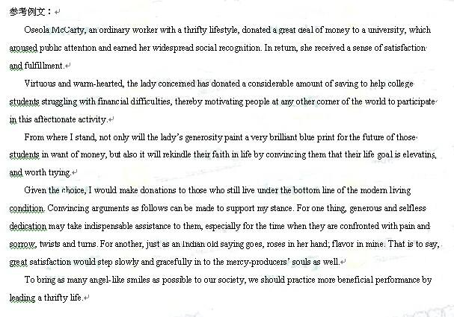
6. It isn’t hard to grow up into a responsible member of society.
I can well remember an incident that happened on a rainy Sunday afternoon. I was on my way to the bookstore and was waiting for the green light at a crossing when a girl of about ten was knocked down by a passing car, which drove off quickly. A man immediately rushed to the girl to give her first aid and I joined in without hesitation. Luckily she was not badly injured and we sent her to the nearest hospital. Compared with the escaped driver, I am proud of what I did.
As a member of the society, I am aware that being responsible is what it takes to make a better society.
7. 支持：
Today, more and more English words find their way into the Chinese language. Even the Dictionary of Contemporary Chinese includes 239 English words. Some people support it while others do not.
Generally, I am in favour of the inclusion. As the number of English learners is on the rise, it's not difficult for them to understand these words in Chinese contexts. Besides, it is, on some occasions, more convenient to use English words. Most people nowadays use "IT" instead of its translation " xinxi jishu. " In our global village, we can see that it's not uncommon for one language to borrow words from other languages. In English, there are many words borrowed from Latin, French, or even Chinese. In fact. Chinese has never stopped taking words from other languages, say, "ganhu" or "minzhu" from Japanese.
So, it's safe to conclude that it is reasonable to include English which facilitates daily communication.
反对：
With English words getting popular in both media and daily life, a Chinese dictionary has included 239 of them, leaving the public divided into two opposing groups: "For" and "Against."
I tend to take the " Against" side for two reasons. Firstly, this inclusion has actaally
polluted our motlier tongue. Sooner or later, many English accents will rise and fall with the four Chinese tones. And, rules don't tell us how to pronounce such English-turned Chinese words as "wifi" and "Out" in a Chinese way! Secondly, such an inclusion may give rise to prejudices of the educated against those with little knowledge of English. Just for one illustration, while college students take " Bye-bye" for granted when parting from each other, it may unconsciously hurt the feelings of someone who is used to "zaijian."
In short, not only has the inclusion poisoned Chinese, it may also bring about
distance between the Chinese people.
8. Good morning, everyone! It is my honour to be here to share with my opinions on what to learn in senior high school.
In the coming three years , our school life will be challenging. First ,we should learn to learn efficiently. Personally, I used to try effective method to achieve my academic goals. Developing a goood habit is also of importance. It really benefited me a lot to preview lessons, get actively involved in class, and review what had been taught after class.
In addition, we should learne how to get along well with others. In school, I respected teachers and was friendly with classmates. It was with sincerity and faithfulness that we created a harmonious atmosphere.
Finally, we should take part in sports and outdoors activities frequently. They were really helpful to build up my body and enrich my school life.
No pains no gains. I am sure that with great efforts ,you will enjoy a colorful and fruitful life here.
Thank you!
9.
NOTICE
An exciting event “Innovations on Campus” is around the corner. Every one of you is expected to be part of the event which encourages creative minds and gives full play to your DIY skills.
Note that your innovations must be school things. Along with your wonderful innovation, you need to hand in a report, explaining how the idea occurs to you and what materials you use.
All the collections will be on show from June 16 to 18 in the gym. Looking forward to the prize-giving ceremony? Sure! It’ll be held from 15:00 to 17:00 on June 18. So don’t miss the chancc of being the winner. Your contribution will certainly make the event a huge success. For any questions, call Li Hua at 44876655.
Come on, everybody! It’s your show time.
Students’ Union

